- Define Regular Language.
A regular language is a formal language that can be defined by a regular expression or, equivalently, recognized by a finite automaton (DFA or NFA). It relies on finite memory, meaning it cannot count or remember arbitrary nested structures (like balanced parentheses).
- Differentiate DFA and NFA.
DFA (Deterministic Finite Automaton) | NFA (Nondeterministic Finite Automaton)
For each state and input symbol, there is exactly one transition. | For each state and input symbol, there can be zero, one, or multiple transitions.
No epsilon (ε) transitions allowed. | Epsilon (ε) transitions are allowed (move without consuming input).
Easier to implement in code (deterministic). | Harder to simulate directly (requires backtracking or subset construction).
Generally requires more states for the same language. | Often requires fewer states for the same language.
Every DFA is an NFA, but not vice versa (though every NFA can be converted to an equivalent DFA). | More expressive in definition, but no more powerful in terms of languages recognized.
- What is ε-move in NFA?
An ε-move (epsilon transition) is a transition in an NFA that allows the automaton to change states without consuming any input symbol.

It acts as a "free jump" or "spontaneous" move.

It is denoted by the Greek letter ε (epsilon) on the transition arrow.

It is useful for modeling optional operations, union, or concatenation in regular expressions.

The NFA can take ε-moves before, after, or between reading input characters.

- Define Lexical Analysis.
Lexical analysis is the first phase of a compiler.
It reads the source code as a stream of characters and groups them into meaningful sequences called tokens (e.g., keywords, identifiers, operators, punctuation).

It skips whitespace and comments.

It is typically implemented using a finite automaton (DFA) and regular expressions.

It outputs tokens to the next phase (syntax analysis/parser).

- What are Applications of Finite Automata?
Lexical analysis (scanning tokens in compilers/interpreters).

Text processing (regex matching in search, grep, sed, and find/replace).

Pattern recognition (validating email, phone numbers, zip codes).

Network protocols (specifying and validating state machines like TCP/IP).

Digital circuit design (finite-state controllers for hardware).

Natural language processing (morphology and tokenization).

Spell checking (dictionary lookup and correction suggestions).

Game AI (finite-state behavior for NPCs).
- Write the advantages of DFA over NFA.
Determinism: Exactly one transition per input symbol, so no ambiguity or backtracking.

Faster Execution: Simple O(n) table lookup; no need to manage multiple parallel paths (subset simulation).

No ε-moves: Eliminates the overhead of computing ε-closures during processing.

Easier to Implement: Straightforward to code using a 2D transition table or a switch-case.

Predictable Memory: Uses constant memory (only tracks the current state).

Hardware Friendly: Easier to synthesize directly into digital logic circuits.

- What is a Regular Expression?
A regular expression is a sequence of characters that defines a search pattern.

Used to match, find, or replace substrings in text.

Built using three basic operations: union (|), concatenation, and Kleene star (*).

Matches exactly the class of languages recognized by finite automata (regular languages).

Widely used in lexical analysis, text editors, grep, and programming languages (e.g., Python, JavaScript, Perl).

- Explain the term Alphabet and String.
Alphabet (Σ): A finite, non-empty set of symbols/characters (e.g., {0,1} for binary, or {a,b,c}).

String (or Word): A finite sequence of symbols drawn from an alphabet (e.g., "101" over {0,1}, or "cat" over {a,b,c}).

Empty string (ε): The unique string of length zero, containing no symbols.

- What is the role of Lex tool?
Lex (and its GNU version Flex) is a lexical analyzer generator.

It takes a specification file containing regular expressions and corresponding actions (in C code).

It automatically generates a C program that implements a DFA-based scanner.

This scanner reads input characters and outputs tokens when a pattern matches.

It is primarily used in compilers, text processing tools, and parsers (often paired with Yacc/Bison).

- Give an example of language recognized by DFA.
Language: All binary strings that end with 01.
DFA:
- States: {A, B, C} (A = start, B = saw 0, C = accepting saw 01)
- Alphabet: {0,1}
- Transitions:
  - A --0--> B, A --1--> A
  - B --0--> B, B --1--> C
  - C --0--> B, C --1--> A
- Start state: A
- Accept state: {C}
Accepted strings: 01, 101, 001, 0101, etc.
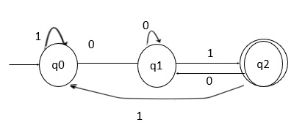
Design a DFA to accept binary strings divisible by 3.
Design a Deterministic Finite Automaton (DFA) that accepts all binary strings (over alphabet {0,1}) that, when interpreted as a binary number, are divisible by 3.
DFA Definition
States: {q0, q1, q2} where q0 = remainder 0, q1 = remainder 1, q2 = remainder 2

Alphabet: {0, 1}

Start state: q0 (empty string represents number 0, which is divisible by 3)

Accepting state: q0 (remainder 0 means divisible by 3)

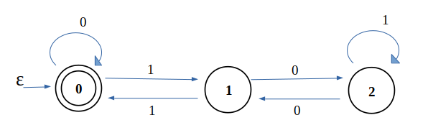

You can convert a regular expression to an NFA (Non-deterministic Finite Automaton) using Thompson's Construction, which relies on five core base and recursive rules.The 5 Core Rules of Thompson's Construction
Rule 1: Empty Set (∅)Create a start state and a final state with no transition between them.
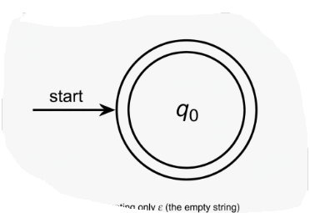
Rule 2: Epsilon (ε)Create a start state and a final state connected directly by an ε-transition.
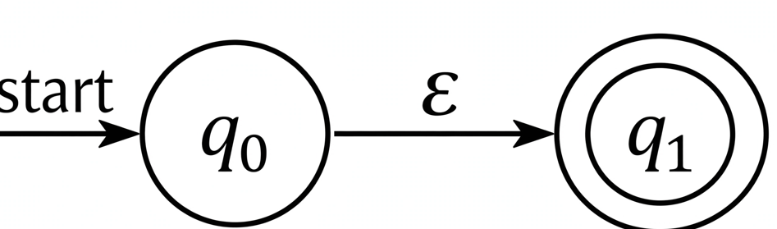

Rule 3: Single Symbol (a)Create a start state and a final state connected by a transition labeled with the symbol a.
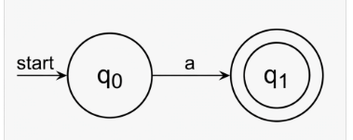
Rule 4: Union (\(R_1 \mid R_2\))Create a new start state and a new final state.Add ε-transitions from the new start to the start states of R₁ and R₂.Add ε-transitions from the final states of R₁ and R₂ to the new final state.
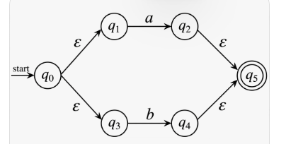
Rule 5: Kleene Star (\(R^{*}\))Create a new start state and a new final state.Add an ε-transition from the new start to the old start and straight to the new final state.Add an ε-transition from the old final back to the old start and over to the new final state.(Note: Concatenation R₁ R₂ acts as the bridging rule, connecting R₁'s final state to R₂'s start state via an ε-transition).
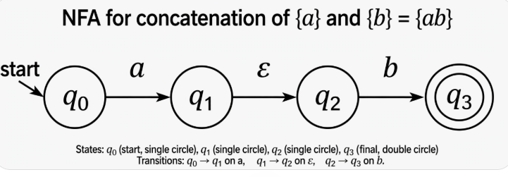
NFA for a*
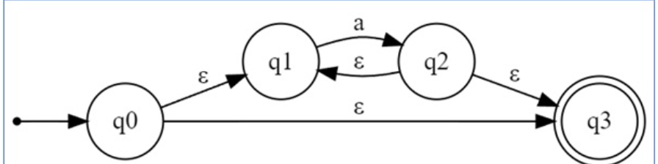

NFA for a+
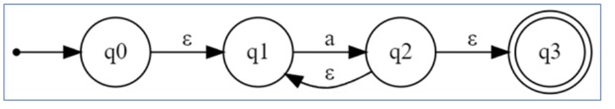

NFA for (ab + c)*
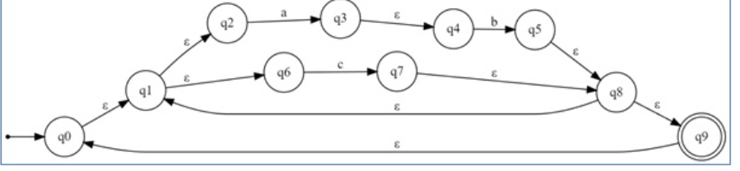

Convert an NFA into equivalent DFA with an example.
An NFA can have zero, one or more move from a given state on a given input symbol. An NFA can also have NULL moves (moves without input symbol). On the other hand, DFA has one and only one move from a given state on a given input symbol.

Steps for converting NFA to DFA:
Step 1: Convert the given NFA to its equivalent transition table

Step 2: Create the DFA's start state

Step 3: Create the DFA's transition table

Step 4: Create the DFA's final states
The DFA's final states are the sets of states that contain at least one final state from the NFA.
Consider the NFA

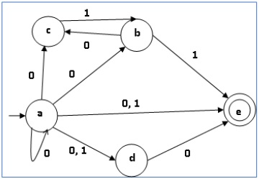

State transition table of NFA
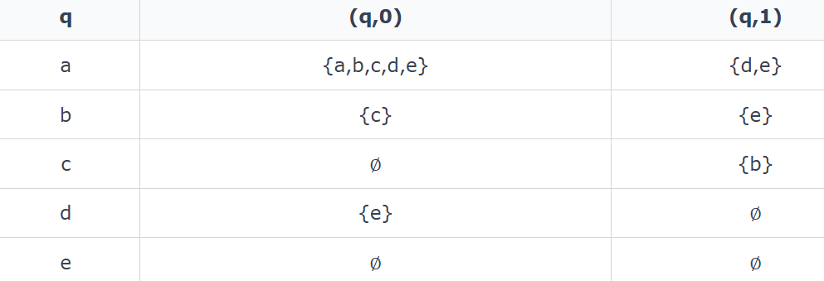

State transition table for DFA
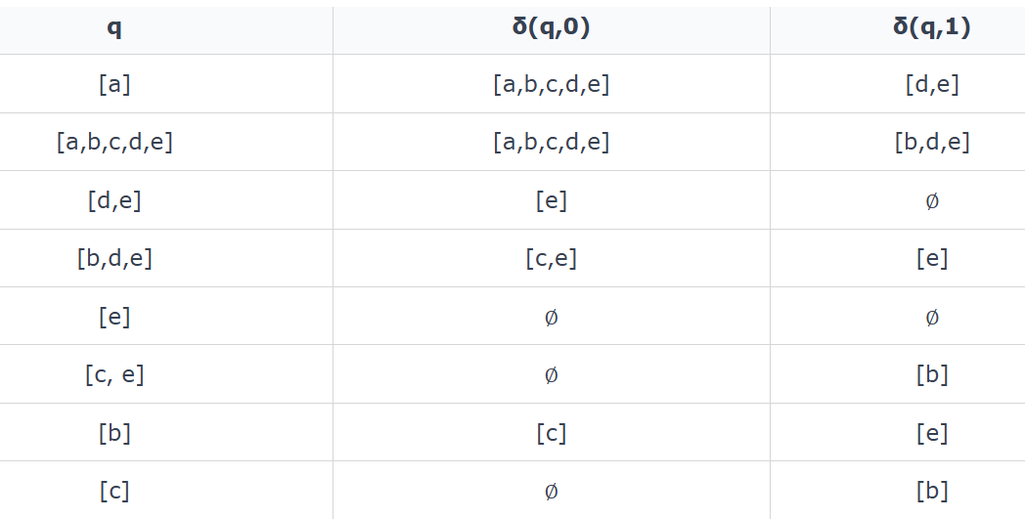

State diagram for DFA
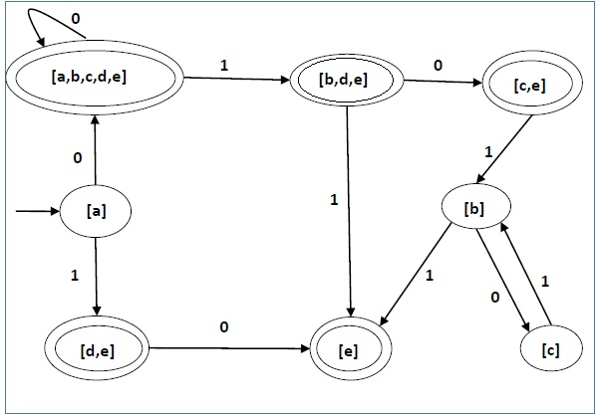

Explain the applications of Finite Automata in Compiler Design.
In Compiler Design, Finite Automata is the heart of Phase 1 - Lexical Analysis. The compiler doesn't understand source code as text, it converts Regex specifications of tokens into FA.

The Main Application: Lexical Analyzer / Scanner
This is where FA is used 90%.
1. Tokenization
The scanner reads source code character by character and groups them into tokens: keyword, identifier, number, operator, delimiter.
Every token type is defined by a Regular Expression, and every Regular Expression is implemented as a Finite Automata.
Example:
- Identifier: [a-zA-Z_][a-zA-Z0-9_]* → NFA → DFA
- Integer: [0-9]+
- Keyword if: exactly i f
The DFA runs over the input and whenever it reaches a final state, it has found a token.
2. Keyword vs Identifier Separation
FA first accepts all words as identifiers, then a lookup table checks if it's a reserved keyword. The FA for the identifier is
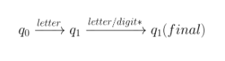

3. Removing White-space and Comments
FA has dead / trap states. On seeing , \n, \t or // or /* */ it goes to a loop that consumes and discards them, doesn't generate a token.
4. Error Detection in Lexical Phase
If at any point no transition exists from current state on input character, FA goes to error state. Example: identifier starting with digit 9abc → lexical error.
5. Construction Pipeline in Tools like LEX / FLEX
This is how compiler-compilers work:
Code
Regular Expression (rules.l) ↓ Thompson's ConstructionNFA with ε-moves ↓ Subset ConstructionDFA ↓ Hopcroft's MinimizationMinimized DFA → C code for scanner (lex.yy.c)
2 lines hidden
You write regex, tool gives you the FA.
6. Other places FA is used:
- Syntax Analysis: Though PDA/CFG is used, finite automata are used to build LR(0), SLR, LALR parsing tables - the parser itself is a DFA of item sets.
- Code Generation: For pattern matching in instruction selection (BURS).
- Optimization: Data-flow analysis uses finite state abstraction to track variable states.
In short:
Regex = Specification, NFA/DFA = Implementation of Lexer.
Without FA, the compiler cannot distinguish int a = 10; into 5 tokens: int, a, =, 10, ;.

Explain the working of Lex tool with example.
Lex is a computer program or tool designed to automatically generate a lexical analyzer (also called a lexer or scanner), which serves as the crucial first phase of a compiler. It reads a high-level source code file character-by-character and groups them into meaningful units called tokens (such as keywords, identifiers, constants, and operators) while stripping away comments and whitespaces. [1, 2, 3]

⚙️ How the Lex Tool Works (Compilation Workflow)
The transformation from a raw pattern rule file into a functioning token generator involves a distinct three-step process: [1, 2, 3]
[ Your Rules ] -> ( lex.l ) ---> [ Lex Compiler ] ---> ( lex.yy.c )
│
[ Token Stream ] <- ( a.out ) <-- [ C Compiler ] <────────┘
│
(Input Code Text)
- Step 1: Write Specifications – The developer creates a source file with a .l or .lex extension (e.g., lex.l) containing rules written in the Lex language. These rules map Regular Expressions (patterns) to Actions (C code blocks). [1, 2, 3, 4]
- Step 2: Generate C Code – The lex.l file is fed into the Lex Compiler. Lex processes the regular expressions, builds an internal Deterministic Finite Automaton (DFA) state machine, and outputs a pure C source file named lex.yy.c. [1, 2]
- Step 3: Build Executable – The lex.yy.c file is compiled using a standard C Compiler (like gcc). This outputs an executable file (traditionally named a.out). When a.out runs, it scans incoming text streams and breaks them down into your designated tokens. [1, 2, 3, 4]

📝 Structure of a Lex Program
A Lex specification file is strictly divided into three sections separated by double percent signs (%%): [1, 2, 3, 4, 5]
lex
{ Definition Section }
%%
{ Rules Section }
%%
{ User Subroutines Section }
Use code with caution.
- Definition Section: Enclosed in %{ and %}. It contains raw C code declarations (like #include <stdio.h> or global variables) alongside macro definitions for shortcuts. [1, 2, 3, 4, 5]
- Rules Section: The core logic consisting of Pattern { Action } pairs. When text matches a pattern (Regular Expression), the corresponding C code block executes. [1]
- User Subroutines Section: Contains standard C functions, crucially including the standard main() function. The main() function initiates the token scanner by invoking the built-in Lex function yylex(). [1, 2, 3, 4]

💡 Example: Token Recognizer Program
Below is a complete, standard Lex program designed to distinguish between basic numbers, keywords, and identifiers: [1, 2]
lex
%{
#include <stdio.h>
%}

%%
if|else|while|int|return { printf("KEYWORD: %s\n", yytext); }
[a-zA-Z][a-zA-Z0-9]* { printf("IDENTIFIER: %s\n", yytext); }
[0-9]+ { printf("NUMBER: %s\n", yytext); }
[ \t\n] { /* Skip all whitespaces, tabs, and newlines */ }
. { printf("UNKNOWN CHARACTER: %s\n", yytext); }
%%

int main() {
printf("Enter code snippet to tokenize:\n");
yylex(); // Launches the lexical analysis state machine
return 0;
}

int ywrap() {
return 1; // Directs Lex to terminate execution when input ends
}
Use code with caution.
Key Built-In Variables Used:
- yylex(): The fundamental execution function generated by Lex to read the input stream.
- yytext: A character pointer array containing the exact string text matched by the current rule.
- ywrap(): A status function called by Lex when the input reaches the End-Of-File (EOF). Returning 1 terminates scanning. [1, 2, 3, 4, 5]
Sample Execution Result:
If you supply the generated analyzer executable with this input string:
c
int num = 42
Use code with caution.
The console will output the following token breakdown:
text
KEYWORD: int
IDENTIFIER: num
UNKNOWN CHARACTER: =
NUMBER: 42

Discuss closure properties of Regular Languages.
A closure property means that if you perform a specific operation on one or more regular languages, the resulting new language is also regular. Regular languages are closed under basic set operations, regular operations, and language transformations.Core OperationsUnion (\(L_1 \cup L_2\)): Combining two regular languages yields another regular language.Intersection (\(L_1 \cap L_2\)): The common strings shared by two regular languages form a regular language.Complement (\(\overline{L}\)): All strings over the alphabet that are not in the regular language L still form a regular language.Set Difference (L₁ - L₂): Strings in L₁ that are not in L₂ result in a regular language.Concatenation (L₁ L₂): Joining strings from L₁ followed by L₂ creates a regular language.Kleene Star (\(L^{*}\)): Repeating a regular language zero or more times stays regular.Reversal (\(L^{R}\)): Reversing every string in a regular language produces a regular language.Advanced TransformationsHomomorphism: Replacing each symbol in a language's alphabet with a string yields a regular language.Inverse Homomorphism: The pre-image of a regular language under a homomorphism mapping is regular.Quotient: The quotient of a regular language with any other language (regular or not) remains regular.If you want, I can provide:The proofs for union, intersection, or complement using automataHow to use these properties to prove a language is not regular (the Pumping Lemma)

Prove that Regular Languages are closed under Union operation.
Regular languages are closed under the union operation, meaning that if L₁ and L₂ are regular languages, their union \(L_1 \cup L_2\) is also a regular language. [1]
Proof Using Nondeterministic Finite Automata (NFA)
An easy way to prove this is by using NFA construction. [1]
- Given: Let L₁ and L₂ be two regular languages. [1]
- Machines: By definition of regular languages, there exist two NFAs, M₁ = (Q₁, Σ, δ₁, q₁, F₁) and M₂ = (Q₂, Σ, δ₂, q₂, F₂), that recognize L₁ and L₂ respectively. [1, 2, 3, 4]
- Construction: We build a new NFA \(M = (Q, \Sigma, \delta, q_0, F)\) to recognize \(L_1 \cup L_2\):
  - Add a new start state q₀.
  - Add ε-transitions (empty string transitions) from q₀ to the original start states q₁ of M₁ and q₂ of M₂.
  - Keep the original states, alphabet, and accept states: \(Q = \{q_0\} \cup Q_1 \cup Q_2\), and \(F = F_1 \cup F_2\).
  - Define the transition function δ so that it includes all original transitions of M₁ and M₂, plus \(\delta(q_0, \varepsilon) = \{q_1, q_2\}\). [1, 2]
Conclusion
When an input string is run on the new machine M, it immediately branches via an ε-transition to either M₁ or M₂. The machine M accepts the string if and only if it is accepted by M₁ or M₂. Therefore, M accepts the language \(L_1 \cup L_2\), proving that the union of two regular languages is regular. [1, 2]
Would you like to see an alternative proof for this property using regular expressions or the product construction for DFAs?

Construct NFA for (a+b)*abb.

NFA for a+b

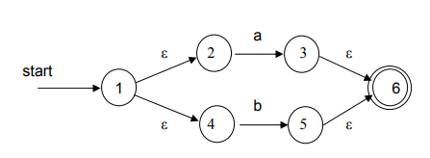

NFA for (a+b)*
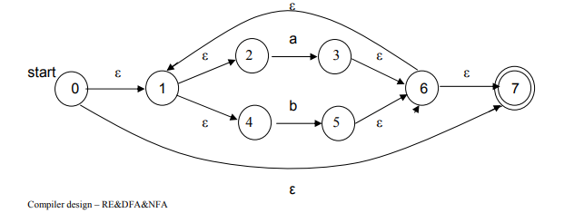

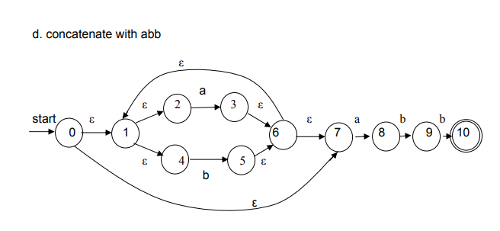

Explain difference between Lexical Analysis and Parsing.

Lexical Analysis vs. Parsing (Brief)
Lexical Analysis breaks program into tokens (words), while Parsing checks the token sequence against grammar rules (sentence structure).
Feature | Lexical Analysis | Parsing
Input | Source code (character stream) | Token stream
Output | Tokens (e.g., ID, NUMBER, IF) | Parse Tree / Abstract Syntax Tree (AST)
Grammar | Regular (Type 3) | Context-Free (Type 2)
Automaton | Finite Automaton (DFA/NFA) – No stack | Pushdown Automaton (PDA) – Uses a stack
Capability | Recognizes simple patterns (identifiers, numbers) | Handles nested/recursive structures (e.g., if(if(...)), parentheses)
Memory | Finite (O(1) space) | Infinite (stack grows with nesting depth)
Error detection | Illegal characters, malformed tokens | Missing semicolons, mismatched brackets
Analogy: Lexical analysis is identifying words in a sentence; parsing is diagramming the grammatical structure (subject, verb, object).

